Sunday  “Promise me you'll always remember: You're braver than you believe, and stronger than you seem, and smarter than you think.” – A.A Milne | Monday | Tuesday | Wednesday | Thursday | Friday | 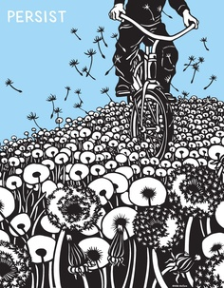  Saturday
13 April | 14 | 15 | 16 | 17 | 18 | 19  To Do:
20 | 21 | 22 | 23 | 24 | 25 | 26
27 | 28 | 29 | 30 | 1 May | 2 | 3

